# Cloud Concierge Extension FAQs

# *If you are a first-time user please take the time to review the “Cloud Concierge Overview” document on the Support page. *

## How can I extend my instance if the allocated time is not enough?

## Why is my Opportunity number getting deleted from the Opportunities List in my ‘Opportunities’ page?

## How come the ‘Extend’ button only grants a 24-hour extension after I added my Opportunity number in my ‘Opportunities’ page?

## Can I request an extension from AskIBM if I do not have a valid Opportunity number?

## If I am not the instance owner, can I still request an extension from AskIBM?

## What is the maximum extension interval granted by AskIBM?

## How can I obtain approval for extensions longer than 3 weeks?

## If my instance has expired, can AskIBM retrieve it for me?

## What is an ‘archive’ and what is it used for?

## What happens to unauthorized users with existing instances?

Cloud Concierge Support Team

## Q: How can I extend my instance if the allocated time is not enough?

To take advantage of our self-service offering to extend your own instance, please follow the instructions listed below:

1. Up to 5 days prior to your expiry date, you can simply enter your Opportunity number in your Opportunities list under the ‘Opportunities’ page in Cloud Concierge.
2. Ensure that your instance is not under the ‘testing’ requirement type.

**Note:** Go to your ‘MyCloud’ page, click the chevron arrow associated with your instance, select ‘Edit Info’ and make sure that ‘Testing’ is not selected.

1. Wait approximately 3 hours for the database to update.
2. Log out of Cloud Concierge for the database updates to take effect, delete all your browsing data, then log back in.
3. Click the chevron arrow associated with your instance in your ‘MyCloud’ page and then select ‘Extend’ to extend your instance in two week intervals.

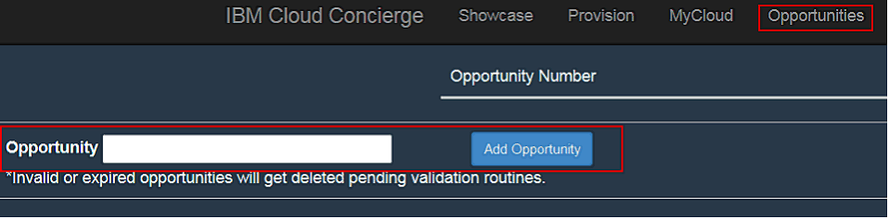

**Note:** If you do not possess a valid Opportunity number or the instance requirement type is under ‘Testing’, you can only extend for an additional 24 hours. For longer duration, please email us with your needs and justification.

## Q: Why is my Opportunity number getting deleted from the Opportunities List in my ‘Opportunities’ page?

The Opportunity number will be deleted from your Opportunities List if it was expired or no longer valid. An Opportunity number is only deemed valid between the Sales Stage of 02 – 07. Please obtain a new and valid Opportunity number from your Sales Representative.

## Q: How come the ‘Extend’ button only grants a 24-hour extension after I added my Opportunity number in my ‘Opportunities’ page?

It is important to note that it takes up to several hours for the database to refresh once you enter your Opportunity number in the Opportunities list, i.e. you cannot extend immediately after entering. Please wait for several hours and log out of your account before logging back in to try again.

## Q: Can I request an extension from AskIBM if I do not have a valid Opportunity number?

We need to capture Opportunity numbers to verify Cloud Concierge’s contribution to revenue generating opportunities. If you are unable to provide a valid Opportunity number, you should provide a solid business justification so we can extend your instance for a maximum period of 5 business days.

## Q: If I am not the instance owner, can I still request an extension from AskIBM?

Unfortunately, we cannot provide extensions to individuals who are not the instance owners. Please contact the instance owner and inform them to send an extension request to AskIBM.

## Q: What is the maximum extension interval granted by AskIBM?

We can only provide extensions in 3 week intervals due to SoftLayer security and compliance regulations, as well it allows us to ensure each opportunity stays active, and helps control costs for server usage. However, exceptions do apply for some cases so please refer to the answers below for more details.

## Q: How can I obtain approval for extensions longer than 3 weeks?

To obtain approval, please first provide your business justification to AskIBM and we will work with our Global Lead to secure approval.

Then we will require the instance owner to choose between the following 2 options due to security and hacker concerns:

1. Register the Instance with IBM’s Mixed Addresses Database MAD (<https://w3-03.sso.ibm.com/services/security/ipaddress/home.action.wss>) which scans and reports vulnerabilities about the system. The Cloud Concierge owner will then be responsible for fixing vulnerabilities found within the system in a timely manner. Please bear in mind that the Cloud Concierge’s user’s management and senior management may be cc’d on vulnerability emails.

**Note:** This option is only available to IBMers and we require Cloud Concierge owners to send us a screen shot of the system registered in MAD.

1. Disable the public IP address which will require you to log into the SoftLayer VPN to access/use the Cloud Concierge instance. This option requires you to email AskIBM asking us to disable the public IP on your behalf.

## Q: If my instance has expired, can AskIBM retrieve it for me?

Once an instance has expired, it is no longer recoverable. To avoid losing your instance, you can create private archives of each image so that your work is saved properly and can easily be re-provisioned as needed. You are allowed to create 2 archives by default (this number can be increased) and they expire after 60 days. However, provisioning from them resets the clock back to day 1 again.

**Note:** Please reference your ‘MyCloud’ page as it contains the expiration dates of all your instances.

## Q: What is an ‘archive’ and what is it used for?

The ‘archive’ button takes a current snapshot of your existing instance and allows you to provision a new instance from it every time you need it. You can create up to two archives. Be advised that the archive template expires after 60 days, but provisioning from them resets the 60 day interval.

To use the archive function, please go to your ‘MyCloud’ page within Cloud Concierge, select the chevron arrow associated with your instance(s) and click ‘Archive’.

To access your archives, please go to your ‘Provision’ page within Cloud Concierge and select ‘My Templates’. **Important:** When performing the archive process, your instance becomes unavailable during the copying process for 2-3 hours.

## Q: What happens to unauthorized users with existing instance(s)?

Cloud Concierge is only available to, and is solely funded by, the IBM Analytics platform. If an activated user in Cloud Concierge does not belong to this organization, we will be forced to revoke their provisioning access. Any active instances will be given a grace period of 48 hours to allow the user to export or backup their work. Revoked users will still have access to Cloud Concierge, but will only be able to access our non-provisionable demo assets.

Alternatively, if you work with IBM Analytics Platform, Solutions and/or IoT Technical Sellers, they may provision and share log in credentials, as long as they maintain control and ownership over any provisioned image. Any concerns about this process should be escalated to your executive management & divisional finance teamto negotiate funding options for use of this system.